**Churn Rate Analysis**

**Churn rate analysis is the process of monitoring and evaluating a company's customer loss rate to understand why customers are leaving and to reduce churn.**

**Key important of Churn Rate**

* Churn analysis can help you understand your company’s churn rates and why customers are cancelling
* It’s important to understand which customer segments are churning and why
* Discovering cancellation reason trends can help you identify specific reasons customers are churning in large numbers so you can adapt as needed
* Sometimes, high churn rates for reasons like pricing may indicate that you’re not targeting the right audience
* Tools like Bare metrics can help you conduct a churn analysis, providing clear metrics, cancellation insights, and even help prevent involuntary churn

**About Dataset**

**Data**Once the Base Samples are installed, if you navigate to Team Content > Samples > Data, you will see a data module that is named Telco customer churn. It contains 5 tables:

* Demographics
* Location
* Population
* Services
* Status.

**Description of each data file**

**Demographics**

* **CustomerID:** A unique ID that identifies each customer.
* **Count:** A value used in reporting/dashboarding to sum up the number of customers in a filtered set.
* **Gender:** The customer’s gender: Male, Female
* **Age:** The customer’s current age, in years, at the time the fiscal quarter ended.
* **Senior Citizen:** Indicates if the customer is 65 or older: Yes, No
* **Married:** Indicates if the customer is married: Yes, No
* **Dependents:** Indicates if the customer lives with any dependents: Yes, No. Dependents could be children, parents, grandparents, etc.
* **Number of Dependents:** Indicates the number of dependents that live with the customer.

**Location**

* **CustomerID:** A unique ID that identifies each customer.
* **Count:** A value used in reporting/dashboarding to sum up the number of customers in a filtered set.
* **Country:** The country of the customer’s primary residence.
* **State:** The state of the customer’s primary residence.
* **City:** The city of the customer’s primary residence.
* **Zip Code:** The zip code of the customer’s primary residence.
* **Lat Long:** The combined latitude and longitude of the customer’s primary residence.
* **Latitude:** The latitude of the customer’s primary residence.
* **Longitude:** The longitude of the customer’s primary residence.

**Population**

* **ID:** A unique ID that identifies each row.
* **Zip Code:** The zip code of the customer’s primary residence.
* **Population:** A current population estimate for the entire Zip Code area.

**Services**

* **CustomerID:** A unique ID that identifies each customer.
* **Count:** A value used in reporting/dashboarding to sum up the number of customers in a filtered set.
* **Quarter:** The fiscal quarter that the data has been derived from (e.g. Q3).
* **Referred a Friend:** Indicates if the customer has ever referred a friend or family member to this company: Yes, No
* **Number of Referrals:** Indicates the number of referrals to date that the customer has made.
* **Tenure in Months:** Indicates the total amount of months that the customer has been with the company by the end of the quarter specified above.
* **Offer:** Identifies the last marketing offer that the customer accepted, if applicable. Values include None, Offer A, Offer B, Offer C, Offer D, and Offer E.
* **Phone Service:** Indicates if the customer subscribes to home phone service with the company: Yes, No
* **Avg Monthly Long-Distance Charges:** Indicates the customer’s average long distance charges, calculated to the end of the quarter specified above.
* **Multiple Lines:** Indicates if the customer subscribes to multiple telephone lines with the company: Yes, No
* **Internet Service:** Indicates if the customer subscribes to Internet service with the company: No, DSL, Fiber Optic, Cable.
* **Avg Monthly GB Download:** Indicates the customer’s average download volume in gigabytes, calculated to the end of the quarter specified above.
* **Online Security:** Indicates if the customer subscribes to an additional online security service provided by the company: Yes, No
* **Online Backup:** Indicates if the customer subscribes to an additional online backup service provided by the company: Yes, No
* **Device Protection Plan:** Indicates if the customer subscribes to an additional device protection plan for their Internet equipment provided by the company: Yes, No
* **Premium Tech Support:** Indicates if the customer subscribes to an additional technical support plan from the company with reduced wait times: Yes, No
* **Streaming TV:** Indicates if the customer uses their Internet service to stream television programming from a third-party provider: Yes, No. The company does not charge an additional fee for this service.
* **Streaming Movies:** Indicates if the customer uses their Internet service to stream movies from a third-party provider: Yes, No. The company does not charge an additional fee for this service.
* **Streaming Music:** Indicates if the customer uses their Internet service to stream music from a third-party provider: Yes, No. The company does not charge an additional fee for this service.
* **Unlimited Data:** Indicates if the customer has paid an additional monthly fee to have unlimited data downloads/uploads: Yes, No
* **Contract:** Indicates the customer’s current contract type: Month-to-Month, One Year, Two Year.
* **Paperless Billing:** Indicates if the customer has chosen paperless billing: Yes, No
* **Payment Method:** Indicates how the customer pays their bill: Bank Withdrawal, Credit Card, Mailed Check
* **Monthly Charge:** Indicates the customer’s current total monthly charge for all their services from the company.
* **Total Charges:** Indicates the customer’s total charges, calculated to the end of the quarter specified above.
* **Total Refunds:** Indicates the customer’s total refunds, calculated to the end of the quarter specified above.
* **Total Extra Data Charges:** Indicates the customer’s total charges for extra data downloads above those specified in their plan, by the end of the quarter specified above.
* **Total Long-Distance Charges:** Indicates the customer’s total charges for long distance above those specified in their plan, by the end of the quarter specified above.

**Status**

* **CustomerID:** A unique ID that identifies each customer.
* **Count:** A value used in reporting/dashboarding to sum up the number of customers in a filtered set.
* **Quarter:** The fiscal quarter that the data has been derived from (e.g. Q3).
* **Satisfaction Score:** A customer’s overall satisfaction rating of the company from 1 (Very Unsatisfied) to 5 (Very Satisfied).
* **Satisfaction Score Label:** Indicates the text version of the score (1-5) as a text string.
* **Customer Status:** Indicates the status of the customer at the end of the quarter: Churned, Stayed, or Joined
* **Churn Label:** Yes = the customer left the company this quarter. No = the customer remained with the company. Directly related to Churn Value.
* **Churn Value:** 1 = the customer left the company this quarter. 0 = the customer remained with the company. Directly related to Churn Label.
* **Churn Score:** A value from 0-100 that is calculated using the predictive tool IBM SPSS Modeler. The model incorporates multiple factors known to cause churn. The higher the score, the more likely the customer will churn.
* **Churn Score Category:** A calculation that assigns a Churn Score to one of the following categories: 0-10, 11-20, 21-30, 31-40, 41-50, 51-60, 61-70, 71-80, 81-90, and 91-100
* **CLTV:** Customer Lifetime Value. A predicted CLTV is calculated using corporate formulas and existing data. The higher the value, the more valuable the customer. High value customers should be monitored for churn.
* **CLTV Category:** A calculation that assigns a CLTV value to one of the following categories: 2000-2500, 2501-3000, 3001-3500, 3501-4000, 4001-4500, 4501-5000, 5001-5500, 5501-6000, 6001-6500, and 6501-7000.
* **Churn Category:** A high-level category for the customer’s reason for churning: Attitude, Competitor, Dissatisfaction, Other, Price. When they leave the company, all customers are asked about their reasons for leaving. Directly related to Churn Reason.
* **Churn Reason:** A customer’s specific reason for leaving the company. Directly related to Churn Category.

**Description of dashboard**

**General Insights:**

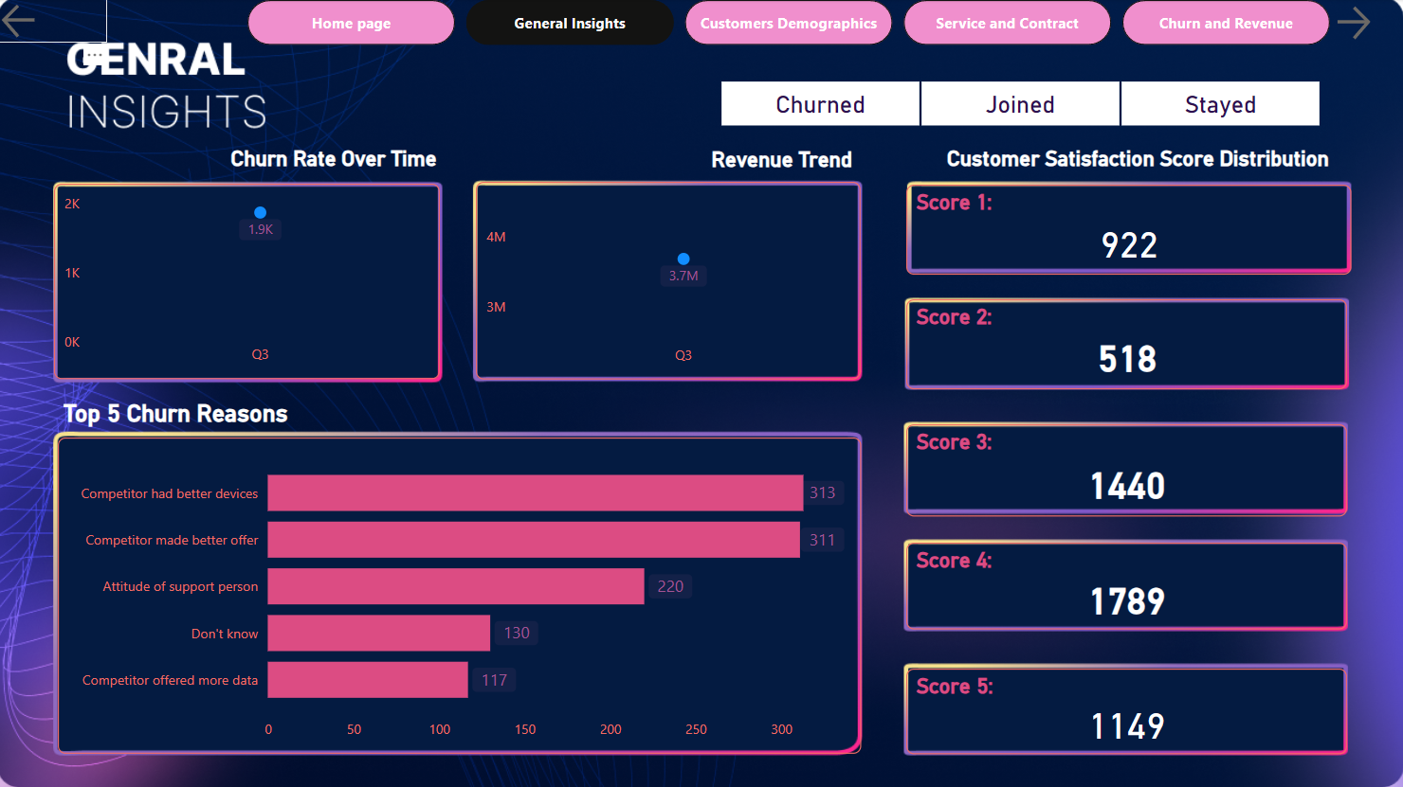

**General Insights:**

* **Churn Rate Over Time:** This chart shows the percentage of customers who have discontinued their service over time. It helps identify trends and patterns in churn rates.
* **Revenue Trend:** This chart illustrates the company's revenue trend over time. It provides insights into the overall financial health of the business.
* **Customer Satisfaction Score Distribution:** This chart displays the distribution of customer satisfaction scores. It helps assess customer sentiment and identify areas where customer satisfaction is high or low.

**Top 5 Churn Reasons:**

* **Competitor had better devices:** This is the most common reason for customer churn, indicating that competitors may be offering more attractive devices.
* **Competitor made better offer:** This suggests that competitors are providing more competitive pricing or promotions.
* **Attitude of support person:** This highlights the importance of customer service in retaining customers. A negative customer experience can lead to churn.
* **Don't know:** This category indicates that customers were unable to provide a specific reason for their churn.
* **Competitor offered more data:** This suggests that competitors may be offering more data allowances, which is a key factor for many customers.

**Other Information:**

* **Churned, Joined, stayed:** This section provides a summary of the number of customers who churned, joined, and stayed with the company.
* **Score 1, Score 2, etc.:** These numbers represent the different customer satisfaction scores. A higher score indicates higher satisfaction.

**Customer Demographic**

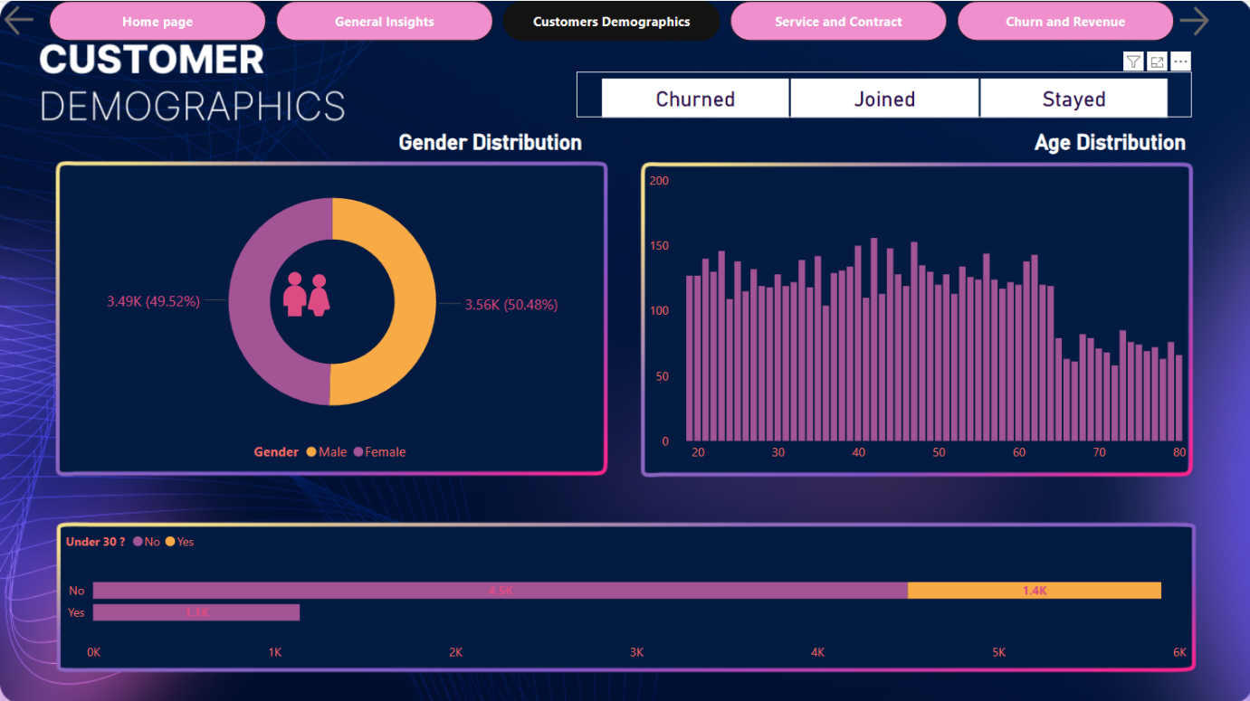

**Gender Distribution:**

* A pie chart shows the percentage of male and female customers.
* The chart indicates that 49.52% of customers are male, while 50.48% are female.

**Age Distribution:**

* A histogram displays the distribution of customer ages.
* The x-axis represents the age range, and the y-axis represents the number of customers within each age group.
* The chart provides insights into the age composition of the customer base.

**Under 30? Yes/No:**

* A bar chart shows the number of customers who are under 30 years old (Yes) and those who are not (No).
* The chart indicates that 1.4K customers are under 30, while the remaining customers are 30 or older.

**Customer Service And Contract Details.**

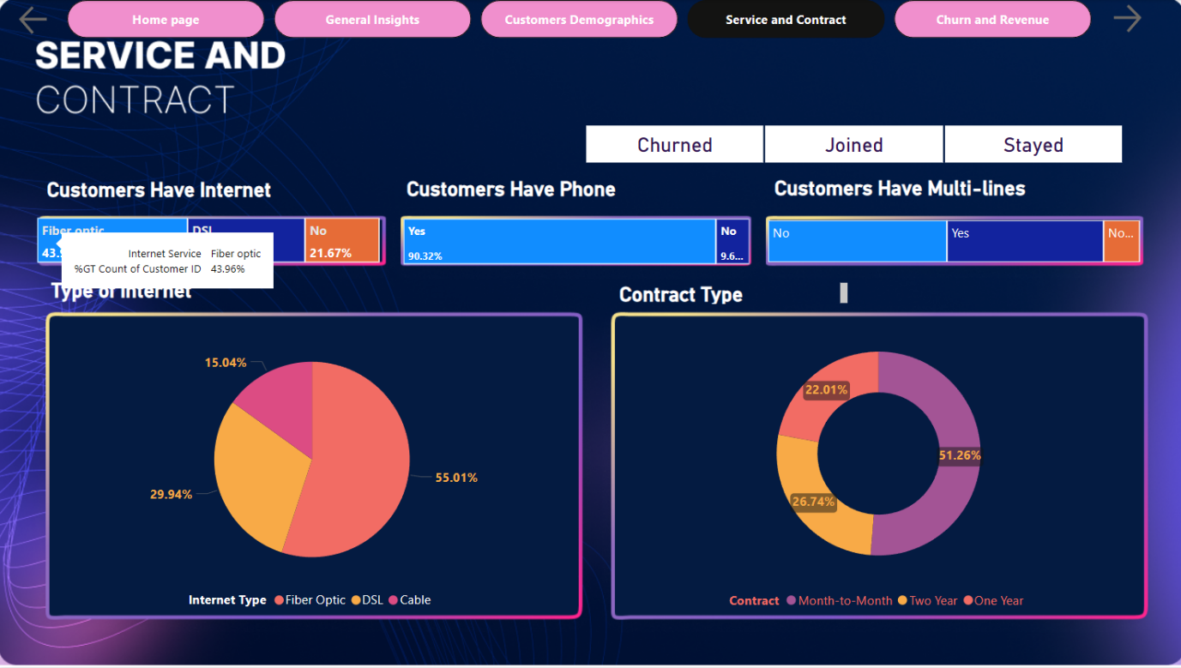

* A table shows the percentage of customers who have internet service, broken down by internet type (Fiber optic, DSL, Cable).
* The table also provides the count of customers for each category.

**Customers Have Phone:**

* A table shows the percentage of customers who have phone service, broken down by whether they have a phone line (Yes/No).
* The table also provides the count of customers for each category.

**Customers Have Multi-lines:**

* A table shows the percentage of customers who have multiple phone lines, broken down by whether they have multi-lines (Yes/No).
* The table also provides the count of customers for each category.

**Type of Internet:**

* A pie chart shows the distribution of internet types among customers.
* The chart provides insights into the popularity of different internet technologies.

**Contract Type:**

* A pie chart shows the distribution of contract types among customers.
* The chart provides insights into the length of customer contracts.

**Churn And Revenue**

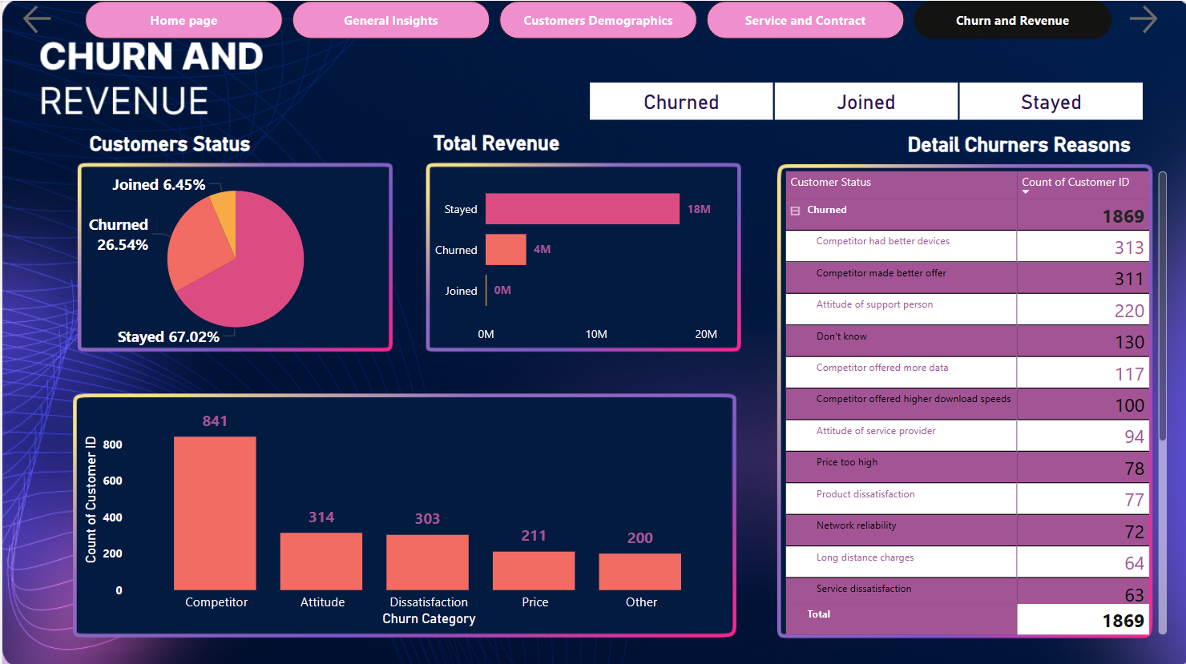

**Customers Status:**

* A pie chart shows the distribution of customer status, including the percentage of customers who churned, joined, and stayed.

**Total Revenue:**

* A line chart illustrates the total revenue trend over time.

**Detail Churners Reasons:**

* A bar chart displays the count of customers who churned due to various reasons, such as competitor offers, customer dissatisfaction, pricing issues, and service quality problems.

**Count of Customer ID:**

* A bar chart shows the number of customers who churned for each of the identified reasons.